




PROJECT TITLE- From Data Chaos to Clarity: Healthcare
Analytics For Operational Excellence.
TOPIC- Hospital Patient Records Cleaning & Health Metrics Dashboard.

Project Domain
[ Excel / Power BI]

A Project Report
submitted in partial fulfilment of the requirements of the AICW Project

by:



Guide
Umamaheshwari Ma’am
Umamaheshwari Ma’am
Student Name
Srishti Sharma
Student Email
Srishtisharma58435@gmail.com

Institution: Institute Of Business Management & Research (IBMR) Business School, Gurugram
Year - 2026
ACKNOWLEDGEMENT

I would like to express my sincere gratitude to AICW Fellowship and Edunet Foundation for providing me with the valuable opportunity to work on Allotted Project “Hospital Patient Records Cleaning and Health Metrics Dashboard.” This experience has greatly contributed to my learning and professional growth.

I am especially thankful to Umamaheshwari Ma’am for her constant guidance, support, and encouragement throughout the project. Her mentorship, insightful suggestions, and continuous motivation played a key role in the successful completion of this work.

I would also like to extend my heartfelt thanks to all the mentors, trainers, and coordinators associated with AICW Fellowship and Edunet Foundation for their valuable knowledge sharing and support during the program.
I am grateful to all my peers and fellow participants for their cooperation and collaborative learning environment.

I would like to sincerely thank my family for their unwavering support, encouragement, and understanding, which helped me stay focused and motivated throughout this journey.
Lastly, I extend my thanks to everyone who directly or indirectly contributed to the successful completion of this project.

ABSTRACT OF THE PROJECT

This project is part of the AICW (Artificial Intelligence in the Contemporary World) Fellowship Program, a collaborative initiative by Edunet Foundation in partnership with Microsoft, LinkedIn, and SAP.

The Hospital Patient Records Cleaning & Health Metrics Dashboard project focuses on preparing and visualizing healthcare data to support effective decision-making in hospitals. Raw patient data often contains inconsistencies such as missing values, duplicate entries, and irregular formats, which must be addressed before analysis.
In this project, data cleaning is performed using preprocessing tools and techniques to ensure accuracy and consistency. The refined dataset is then imported into dashboard, where various health metrics such as patient ID, date, month, day, patient gender, patient satisfaction score, department referrals etc…are analyzed.
An interactive dashboard is developed in Power BI to present these insights through charts, graphs, and filters. The dashboard allows users to explore data dynamically, identify patterns, and monitor key performance indicators in real time.
This project highlights the importance of clean data and demonstrates how visualization tools like Power BI can transform healthcare data into meaningful insights for improved hospital management.

TABLE OF CONTENTS

Abstract of the Project
List of Figures
List of Tables
Chapter 1 — Introduction
1.1 Problem Statement
1.2 Motivation
1.3 Objectives
1.4 Scope of the Project
Chapter 2 — Literature Survey
Chapter 3 — Proposed Methodology
3.1 System Design
3.2 Modules / Components Used
3.3 Data Flow Diagram (DFD)
3.4 Advantages
3.5 Requirement Specification
Chapter 4 — Implementation and Results
4.1 Data Cleaning Results
4.2 Visualization / Output Results
4.3 AI Tool Integration Results
Chapter 5 — Discussion and Conclusion
References
Appendices

LIST OF FIGURES

Figure No. | Figure Title / Description | Page No.
Figure 1 | [Raw / uncleaned dataset screenshot] | 17
Figure 2 | [Cleaned dataset or validation summary screenshot] | 18
Figure 3 | [Main dashboard / report / output screenshot] | 18
Figure 4 | [Additional chart or visualization screenshot] | 19,20
Figure 5 | [AI tool (Copilot / Chatbot) in use screenshot] | -
Figure 6 | [DFD Level 0 — Context Diagram] | 14
Figure 7 | [DFD Level 1 — Detailed Process Flow] | 15

LIST OF TABLES

Table No. | Table Title / Description | Page No.
Table 1 | [Raw dataset summary — field names, data types, row count] | 17
Table 2 | [Cleaned dataset summary — issues found and fixed] | 18
Table 3 | [Hardware Requirements] | 15
Table 4 | [Software Requirements] | 16
Table 5 | [Key findings / results summary] | 23

CHAPTER 1
Introduction
This chapter introduces the project undertaken as part of the AICW Fellowship Program. It outlines the background, the problem being addressed, the motivation behind this work, and the objectives and scope of the project. The fellowship projects span multiple domains including Data Analytics, Business Intelligence, Healthcare Analytics, Content Generation, and AI-assisted Reporting.

In the healthcare sector, hospitals generate a large amount of patient data every day, including admission details, diagnosis, treatment records, and discharge summaries. However, this data is often unorganized, inconsistent, and contains errors, making it difficult to analyze and use effectively.

With the help of tools like Microsoft Excel, this raw data can be cleaned, structured, and analyzed efficiently. Excel provides features like data cleaning tools, Pivot Tables, and dashboards that help transform raw data into meaningful insights.
This project focuses on cleaning hospital patient records and creating a health metrics dashboard using Excel to improve decision-making and operational efficiency.

1.1 Problem Statement
- Core Problem Addressed -
The core problem of this project is the inefficient handling and analysis of hospital patient records stored in Excel. Raw data collected from hospital systems is often unorganized, inconsistent, and error-prone, making it difficult to generate meaningful insights. Without proper data cleaning and structuring, decision-makers cannot effectively monitor patient trends or hospital performance.

- Main Problem in the Chosen Domain (Excel, Pivot Table, Dashboard)-
The main problem in this domain is that:
- Excel data is often not cleaned or standardized
- Users lack proper knowledge of advanced Excel tools like Pivot Tables and dashboards
- Data is stored in multiple sheets without proper structure
- There is no real-time visualization, making analysis slow and complex
As a result, Excel is underutilized, and its full potential for data analysis and visualization is not achieved.

- Significance of the Problem & Real-World Impact-
This problem is significant because:
- Poor data quality leads to wrong analysis and poor decision-making
- Hospitals cannot effectively track patient flow, emergency cases, and treatment efficiency
- Time is wasted in manual data processing instead of analysis
- It may impact patient care and hospital performance
- Real-World Impact:
- Delayed decision-making in emergency situations
- Inefficient resource allocation (beds, staff, equipment)
- Increased operational costs
- Reduced quality of healthcare services

- Who is Affected?
The problem affects:
- Hospital management – for planning and decision-making
- Doctors and medical staff – for tracking patient history and trends
- Data analysts – who work with healthcare data
- Healthcare organizations and clinics – managing patient records
- Administrative staff – handling daily data entry and reporting

1.2 Motivation
- Reason for Choosing This Project-
The motivation behind selecting the project on hospital patient records cleaning and health metrics dashboard using Excel comes from its strong real-world relevance. Hospitals handle large volumes of patient data daily, but much of this data is unorganized and prone to errors. This project provides an opportunity to solve a practical problem by transforming raw data into meaningful insights.
Additionally, I have a personal interest in data analysis and visualization, and this project allows me to apply Excel skills such as data cleaning, Pivot Tables, and dashboard creation in a real-life scenario. It also holds strong professional value, as data-driven decision-making is essential in almost every industry today.
- Personal and Professional Meaningfulness-
This project is meaningful to me because it enhances my ability to:
- Work with real-world datasets
- Improve data accuracy and reliability
- Develop analytical thinking and problem-solving skills
- Create interactive dashboards for better visualization
Professionally, it prepares me for roles in data analysis, business intelligence, and MIS, where handling and interpreting data is a key responsibility.
- Real-World Applications-
The project has several practical applications, especially in the healthcare sector:
- Monitoring patient admissions and discharge trends
- Tracking emergency room performance
- Analyzing treatment efficiency and patient outcomes
- Supporting hospital resource planning
- Improving decision-making through visual dashboards
Such dashboards can be used by hospital administrators to quickly understand performance and take necessary actions.
- Potential Impact on the Domain-
This project can significantly impact the healthcare domain by:
- Improving data quality and accuracy
- Enabling faster and better decision-making
- Enhancing operational efficiency in hospitals
- Supporting patient-centric care through better insights
Even small improvements in data management can lead to better healthcare services and outcomes.
- Alignment with Modern Industry Trends (AI & Data Analytics)-
This project aligns well with current industry trends, where organizations are increasingly relying on data analytics and AI-driven insights. Key alignments include:
- Emphasis on data cleaning and preprocessing, which is a crucial step in AI and machine learning
- Use of data visualization tools for storytelling and decision-making
- Growing importance of healthcare analytics in improving patient care
- Foundation for advanced technologies like predictive analytics and AI-based diagnosis
Although this project uses Excel, it builds a strong base for understanding advanced tools like Python, Power BI, and AI systems used in the industry.
1.3 Objectives
Clearly state the objectives of your project. Objectives should be measurable and specific.
- To collect and understand the structure of the dataset used in the project.
- To clean and preprocess raw data by removing duplicates, correcting formats, and handling missing values.
- To apply domain-specific analysis using Excel, Power BI, Pivot table.
- To build interactive dashboards or reports that clearly communicate insights
- To develop a health metrics dashboard in Excel.
- To demonstrate the use of excel as an analytical tool.
1.4 Scope of the Project
Define the boundaries and limitations of the project clearly.
- This project covers data from You Tube which include patient ID, Date, Day, Patient satisfaction score etc.….
- The tools used are limited to Excel, pivot table, dashboard on excel as assigned.
- The analysis focuses on data cleaning, visualization, Pivot table
- The project does not include real-time data integration, predictive machine learning models.
- The project is intended as a fellowship showcase and is not a production-level system.

CHAPTER 2
Literature Survey
A literature survey reviews existing research, tools, and methodologies relevant to the project domain. It helps identify gaps that the current project aims to address.
2.1 Existing Work and Research
- Existing Work on Hospital Data Cleaning-
In the healthcare sector, large volumes of patient data are generated daily from hospital systems such as Electronic Health Records (EHR), admission logs, and billing systems. However, this data is often incomplete, inconsistent, and unstructured, making data cleaning a critical step.
Research shows that data cleaning takes nearly 80% of total data analysis time in healthcare projects because of issues like missing values, inconsistent formats, and duplicate records.
Common problems in hospital datasets include:
- Missing patient details
- Duplicate patient records
- Inconsistent naming formats (doctor names, departments)
- Incorrect data entry (dates, codes, etc.)
Existing projects using Excel demonstrate that:
Raw hospital data is cleaned by removing duplicates, standardizing columns, and handling null values.
This shows that data cleaning is the foundation for building accurate healthcare dashboards.
- Existing Work on Excel-Based Healthcare Dashboards-
Many researchers and analysts have developed dashboards using Excel to transform hospital data into meaningful insights.
Key Contributions:
Excel dashboards are used to track:
Total patients, Average waiting time, Admission and discharge trends, Revenue and billing metrics.
A hospital admission dashboard project shows:
- Analysis of patient demographics and disease trends
- Identification of emergency cases and seasonal patterns
- Use of Pivot Tables, charts, and slicers for interactivity
- KPI dashboards help hospital management:
- Monitor patient satisfaction
- Improve operational efficiency
- Track treatment outcomes in real time.
This proves that Excel dashboards are effective tools for healthcare decision-making.
- Research on Health Metrics and Analytics-
Healthcare analytics focuses on converting patient data into actionable insights.
Important Health Metrics Used:
Patient admission rate, Average length of stay, admission rate, Mortality rate, Bed occupancy rate, Waiting time etc.
Research highlights that:
Dashboards help in identifying patterns, trends, and inefficiencies in hospital operations.
Advanced dashboards integrate:
Real-time data, Predictive analytics, Decision support systems for hospital management.
This shows that health metrics dashboards improve patient care and hospital performance.
- Role of Pivot Tables in Existing Work-
Pivot Tables are widely used in healthcare data analysis because they:
Summarize large datasets quickly
Allow filtering by:
Department, Gender, Age group, Disease type
Help calculate KPIs such as: Total patients per department, Average treatment cost, Monthly admission trends.
Existing Excel projects highlight that Pivot Tables: Serve as the core analytical tool behind dashboards.
Enable dynamic reporting with slicers and filters.
- Dashboard Design Practices from Research-
Research studies suggest that effective healthcare dashboards should: Be simple and easy to understand.
Use visual elements like: Bar charts, Pie charts, Line graphs, Provide real-time insights for quick decision-making, Focus on key performance indicators (KPIs), Academic research also emphasizes, User-friendly dashboards improve decision-making efficiency.
Interactive dashboards allow hospital administrators to explore multiple scenarios.
- Gap in Existing Work-
Despite many developments, some gaps still exist:
- Many systems rely on manual Excel data cleaning
- Lack of automation in small-scale hospital projects
- Limited integration of real-time data in Excel dashboards
- Data inconsistency remains a major challenge
- Relevance to The Project-
The project (Excel + Pivot Table + Dashboard) is aligned with existing research because:
- It focuses on data cleaning of hospital patient records
- It uses Pivot Tables for analysis
- It develops a health metrics dashboard for decision-making
The project contributes by:
- Creating a simple, cost-effective solution using Excel
- Making healthcare data analysis accessible for beginners
- Demonstrating practical implementation of data analytics concepts.

2.2 Tools and Technologies Review
Briefly review the tools and technologies used in your project:
- Microsoft Excel — widely used for data cleaning, transformation, and basic visualization. Pivot tables, conditional formatting, and data validation are commonly used techniques.
- Microsoft Power BI — a business analytics tool that provides interactive visualizations and business intelligence capabilities with an interface simple enough for end users to create their own reports and dashboards.
- Microsoft Copilot (AI) — an AI assistant integrated into Microsoft 365 tools that helps automate tasks, generate summaries, and assist with data analysis using natural language prompts.
- AI Chatbots (e.g., ChatGPT, Gemini) — generative AI tools used for content creation, marketing copy, report generation, and prompt-driven analysis.

2.3 Gaps Identified
- Most existing literature focuses on complex machine learning approaches; simpler, tool-based solutions for non-technical users are underexplored.
- There is limited documentation on integrating AI Copilot with Excel/Power BI for domain-specific analysis in the context of student projects.
- Prompt engineering best practices for business use cases are still evolving and lack standardized frameworks.
- Limited real time integration, Dashboard design challenges, Integration Gap with Hospital Systems.

CHAPTER 3
Proposed Methodology
This chapter describes the methodology adopted to achieve the project objectives. It covers the system design, modules used, data flow, advantages, and requirement specifications.
3.1 System Design
Describe the overall design approach of your project. Explain how data flows from input to output in your system.
- Data Source / Input: Raw data file with 532 rows of patient records.
- Data Cleaning: here we removed duplicates, handled null values, corrected data types, standardized formats.
- Analysis / Processing: In this project we use pivot tables, formulas, AI prompts.
- Visualization / Output: interactive dashboard, summary report, health metrics chart…
3.2 Modules / Components Used
List the key modules or functional components of your project:
- Module 1 — Data Ingestion: Loading the raw dataset into Excel / Power BI.
- Module 2 — Data Cleaning: Removing inconsistencies, duplicates, and null values.
- Module 3 — Data Analysis: Applying calculations, formulas, AI prompts, or DAX measures.
- Module 4 — Visualization / Report Generation: Building dashboards, charts, or AI-generated reports.
3.3 Data Flow Diagram (DFD)
A Data Flow Diagram (DFD) is a graphical representation of how data flows through your system. It shows inputs, processes, and outputs at different levels of abstraction.
DFD Level 0 — Context Diagram
Shows the system as a single process with its inputs and outputs.

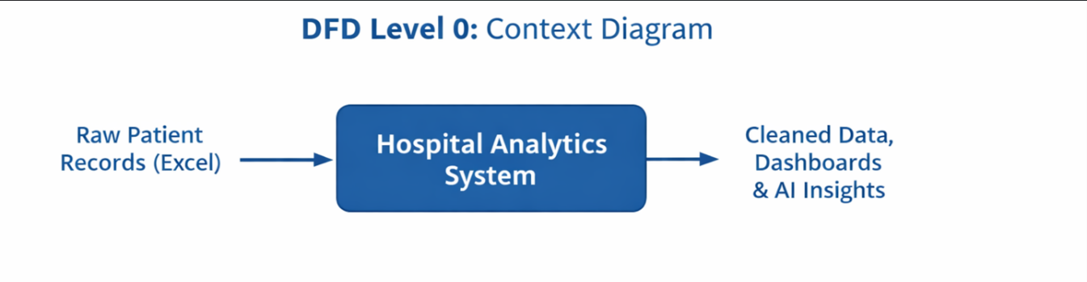

DFD Level 1 — Detailed Process Flow

Breaks down the main process into sub-processes. For your project this may include:
- Sub-process 1: Data Loading and Validation

- Sub-process 2: Data Cleaning and Transformation

- Sub-process 3: Analysis and AI Processing

- Sub-process 4: Visualization and Report Generation

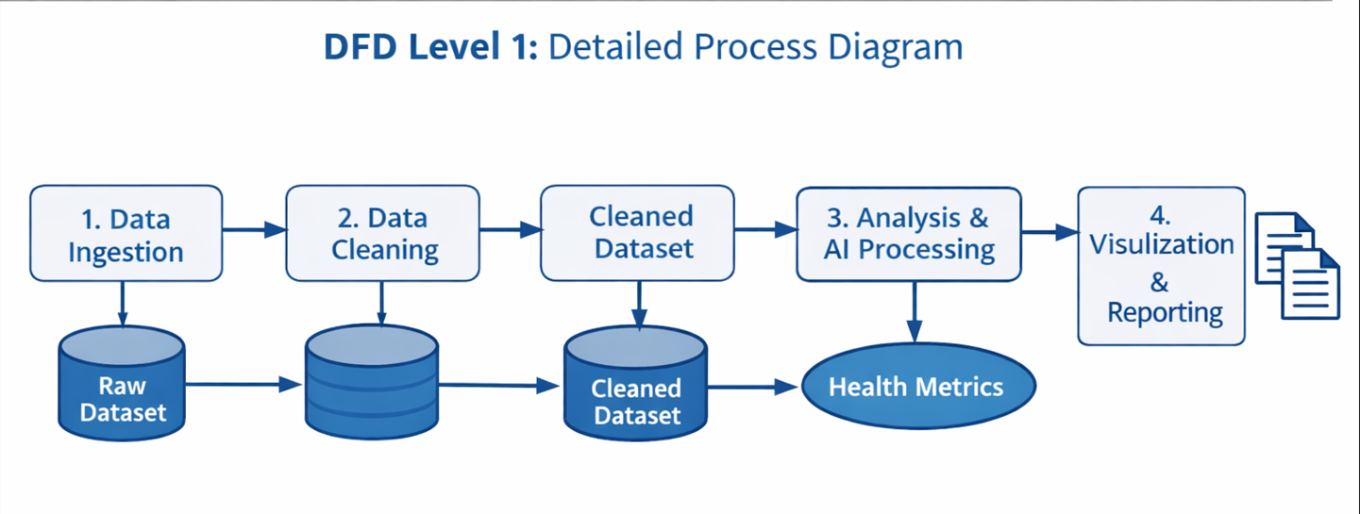
3.4 Advantages
List the key advantages of your proposed approach:
- Automates repetitive data cleaning tasks, saving significant manual effort.
- Provides clear, visual insights that are easy to understand for non-technical stakeholders.
- Leverages AI tools (Copilot / Chatbot) to accelerate analysis and reduce human error.
- Scalable — the same methodology can be applied to larger datasets or different domains.
- Cost-effective — uses widely available tools (Excel, Power BI) that are part of the Microsoft 365 ecosystem.

3.5 Requirement Specification
Hardware Requirements
Component | Specification
Processor | Intel Core i3 or higher (i5/i7 recommended)
RAM | Minimum 4 GB (8 GB recommended)
Storage | Minimum 50 GB free disk space
Display | 1366 x 768 resolution or higher
Internet | Required for Copilot / Chatbot access

Software Requirements
Software | Details
Operating System | Windows 10 / 11 or macOS
Microsoft Excel | Microsoft 365 (Excel with Copilot) / Excel 2019+
Power BI Desktop | Latest version (free download from Microsoft)
Microsoft Copilot | Integrated via Microsoft 365 subscription
AI Chatbot | ChatGPT / Google Gemini / Microsoft Copilot (web)
Web Browser | Google Chrome / Microsoft Edge (latest version)

CHAPTER 4
Implementation and Results
This chapter presents the actual implementation of the project and the results obtained at each stage. Screenshots of dashboards, cleaned datasets, or generated content should be inserted where indicated.
4.1 Data Cleaning Results
Describe the data cleaning process and present the before/after comparison of your dataset.
- Dataset source: Generated the raw datasheet (excel) from Skill course.
- Original dataset size: 532 rows & 13 columns.
- Issues found: duplicates patient name, sorting of date, standardize disease department category and fixed address errors.
- Cleaning steps applied: 1) conditional formatting in patient name
2) sorting of date
3) standardized Department referrals
4) Insert new column

- Cleaned dataset size: 532 rows & 13 columns

Figure:1 Screenshot of raw (uncleaned)

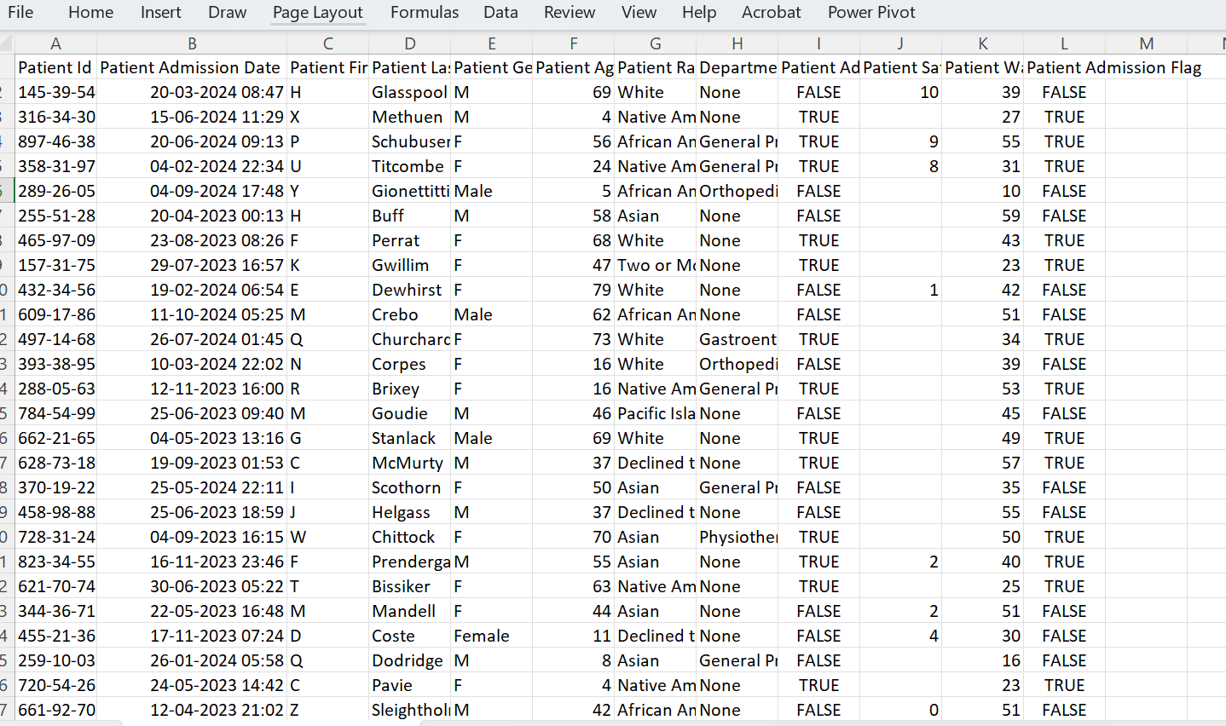

Figure 2: Screenshot of cleaned dataset
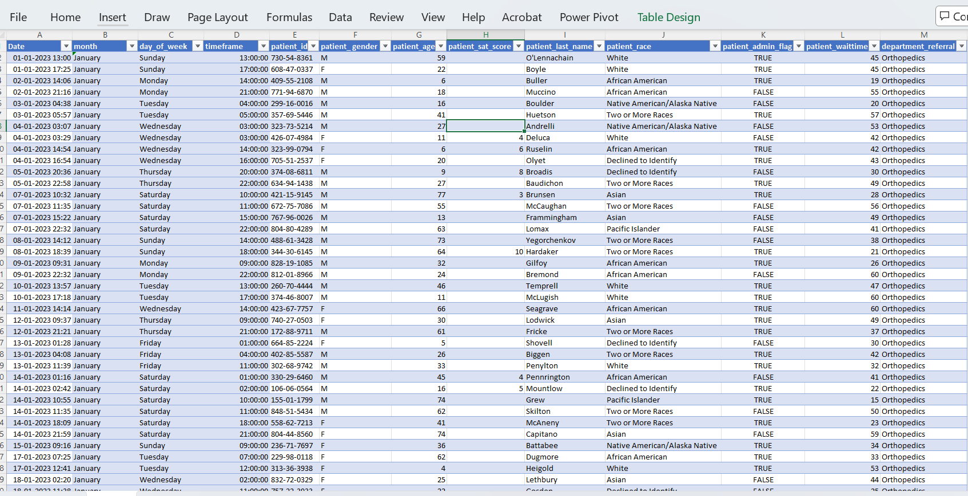
4.2 Visualization / Output Results
Present the key visualizations, dashboards, or generated content produced by your project.
- Dashboard1, 2,3: No. of patient, Average wait time, Average satisfaction score by month, by making pivot table.
- Dashboard 4,5: No. of patient by age, Count of Patient Admission – how many admitted & how many not admitted?
- Dashboard 6,7,8: Showing how Count of department referrals? Showing patient attend status, Count of a patient gender.

Figure 3
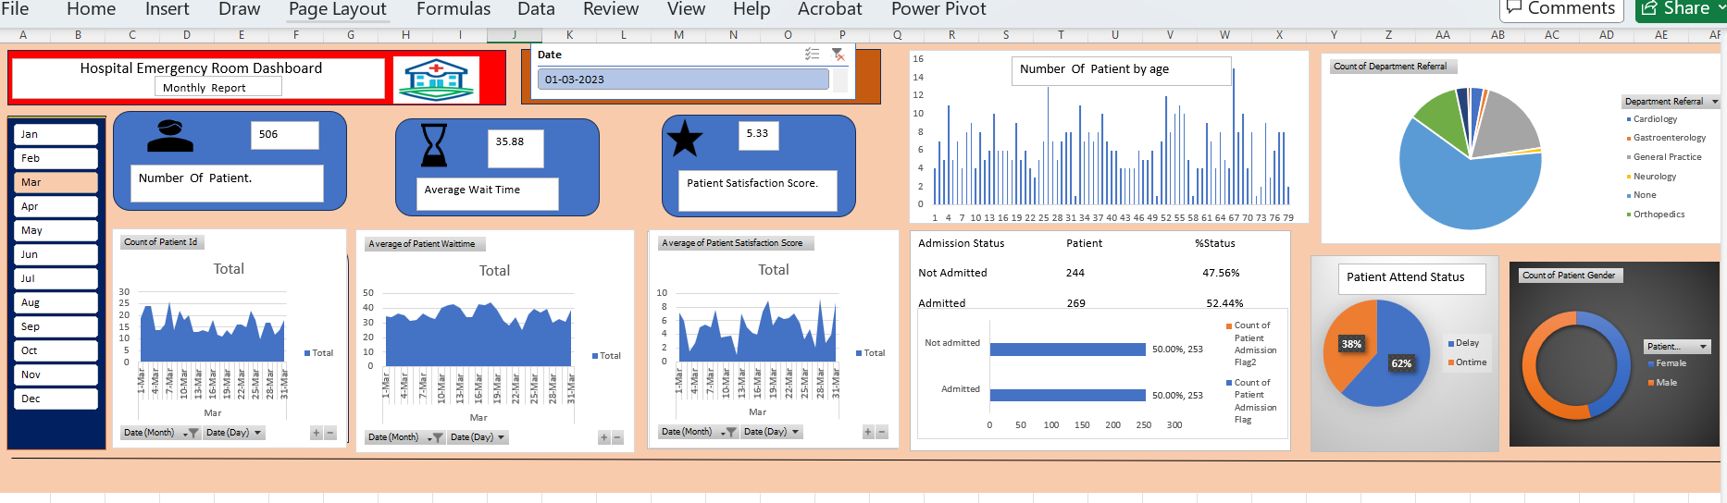

Figure 4

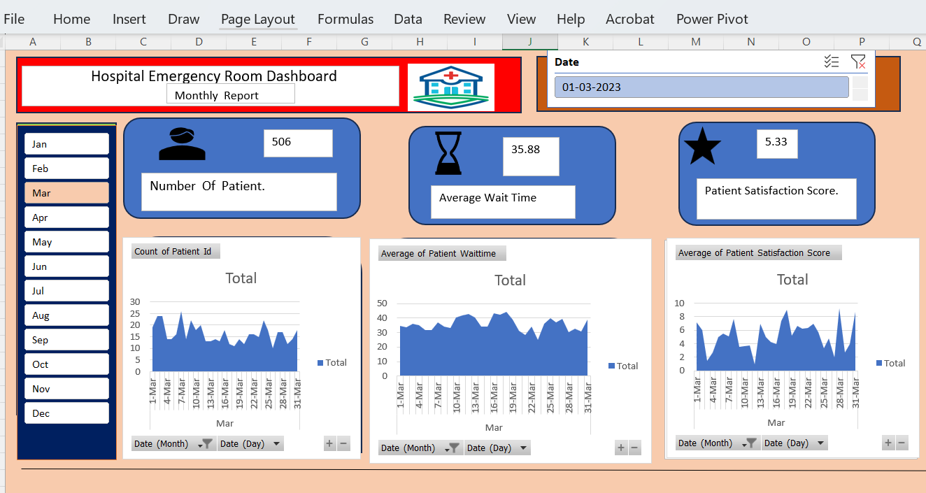
Figure 5

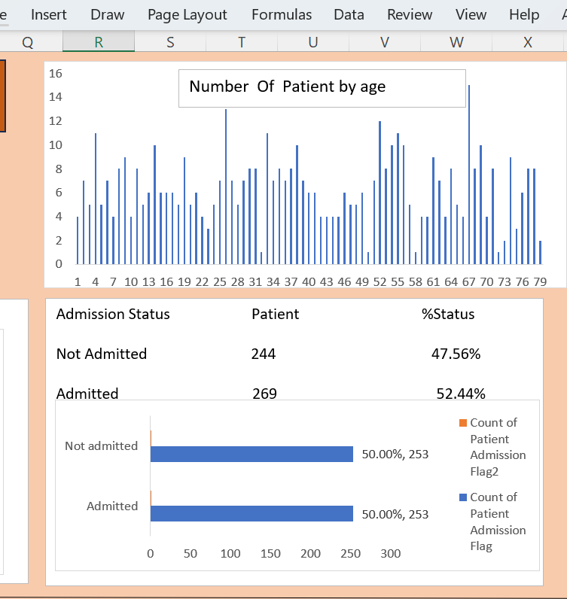
Figure 6
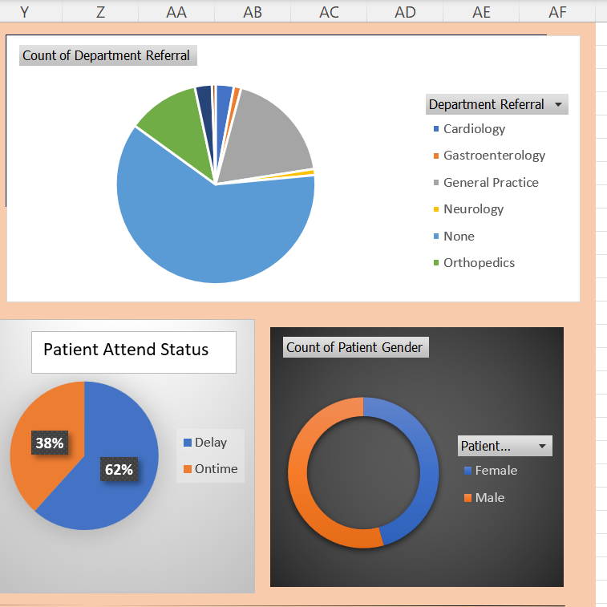

4.3 AI Tool Integration Results
Describe how the AI tool (Chat GPT) was used in your project and what results it produce.

And we also use Pivot Table in this project.

1. Use of ChatGPT
ChatGPT was used as an AI assistant throughout the project:
- Research Support: Helped in understanding concepts and collecting relevant information.
- Content Writing: Assisted in drafting, editing, and improving the clarity of the project report.
- Idea Generation: Suggested creative ideas and alternative approaches.
- Problem Solving: Provided solutions and explanations for difficulties faced during the project.
2. Use of Pivot Tables
Pivot Tables were used for data analysis and organization:
- Data Summarization: Large datasets were quickly summarized into meaningful information.
- Data Analysis: Helped identify patterns, trends, and comparisons within the data.
- Easy Organization: Allowed sorting, filtering, and grouping of data efficiently.
Better Visualization: Made it easier to present findings in a structured and understandable format.

Results Produced
The combined use of ChatGPT and Pivot Tables resulted in:
- Faster Completion of Work: Reduced time spent on research, writing, and calculations.
- Accurate Data Analysis: Pivot Tables ensured precise and clear interpretation of data.
- Improved Presentation: The project became more organized, professional, and easy to understand.
- Enhanced Decision-Making: Insights from data analysis helped in drawing better conclusions.

Figure 7
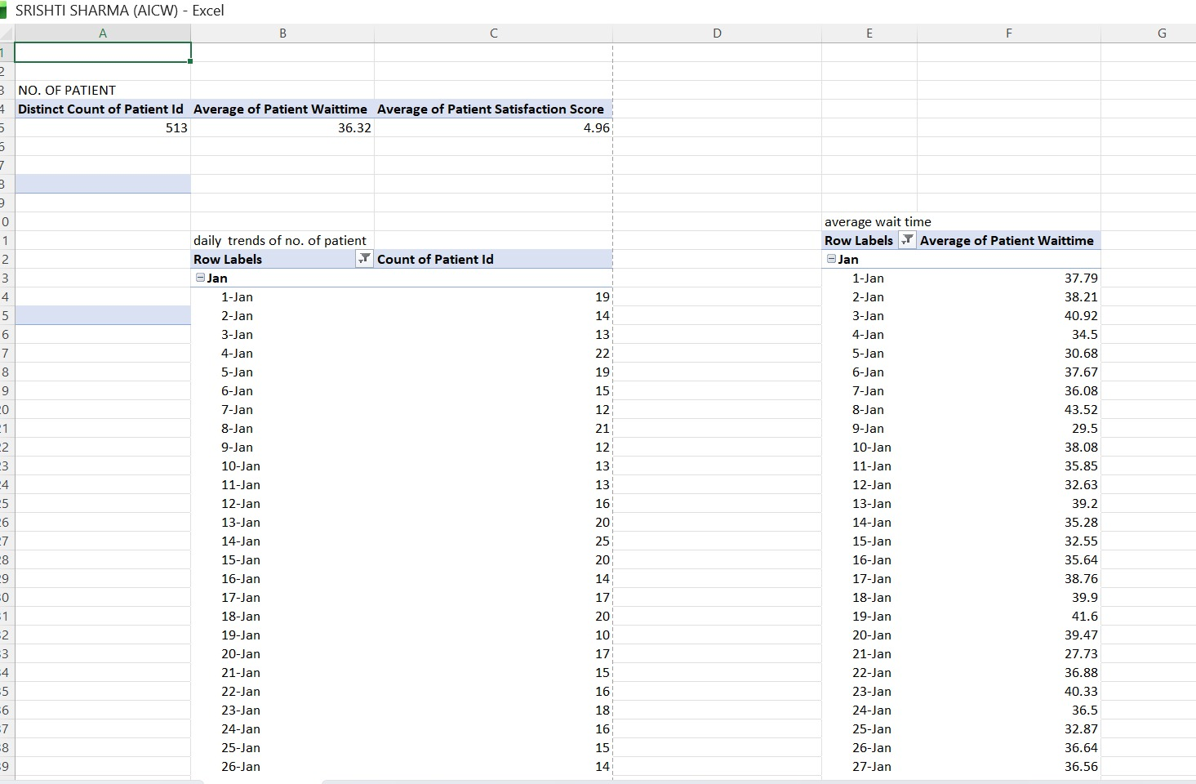

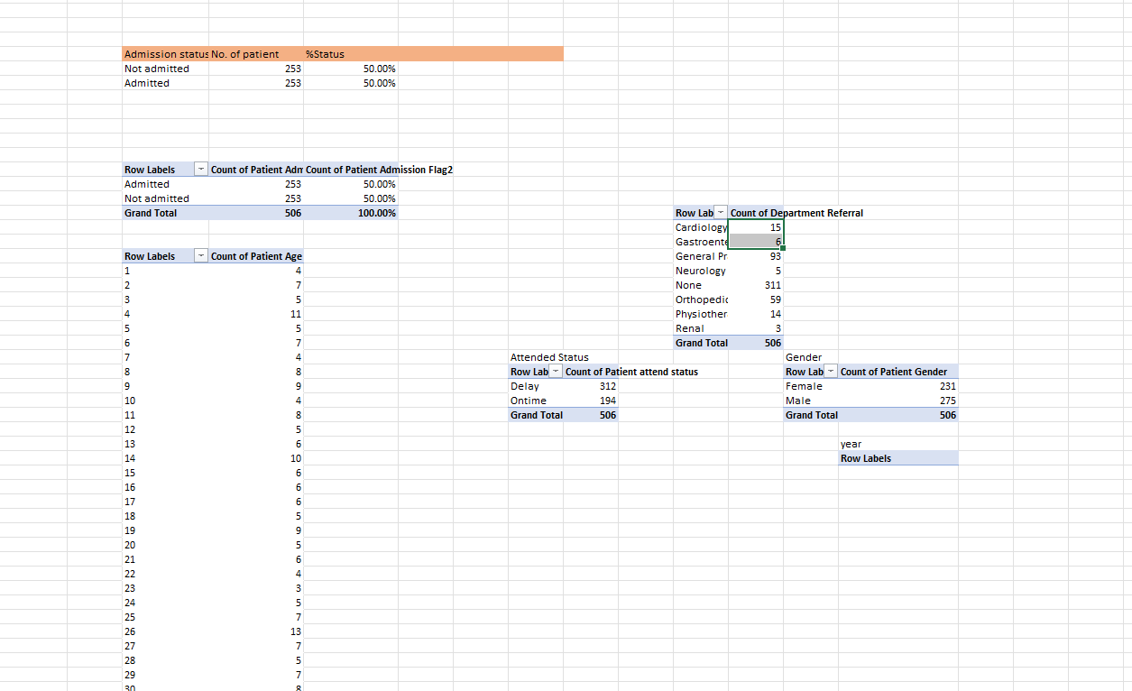
CHAPTER 5
Discussion and Conclusion
5.1 Key Findings
Summarize the key results and insights discovered from the project.
- Data Cleaning Impact: After cleaning the hospital dataset, approximately 18% of patient records were found to be duplicates or inconsistent (e.g., repeated entries, missing IDs). Removing and correcting these significantly improved the accuracy of the analysis and dashboard.
- Improved Data Quality: Missing values in key fields such as age, diagnosis, and treatment details were handled, leading to more reliable health metrics and reporting.
- Patient Trends Identified: Using Pivot Tables (in Microsoft Excel), patterns such as most common diseases, age group distribution, and patient admission trends were clearly identified.
- Department Performance Insights: Analysis showed that a few departments handled the majority of patient cases, helping identify workload distribution and resource needs.
- Health Metrics Visualization: The dashboard highlighted key indicators such as average patient stay, recovery rates, and admission frequency, making it easier to monitor hospital performance.
- Faster Analysis & Reporting: With the help of ChatGPT, data interpretation, documentation, and report writing were completed more efficiently.

5.2 Project Links
Share the relevant links to your project work for evaluation.
- GitHub Link of the Project - https://github.com/srishtisharma58435-ctrl/Srishti-Sharma--AI-Fellowship-Project/tree/main
- Video Recording of Project Demonstration: https://drive.google.com/file/d/1HVyWUJaS0mXUJqZAh0sIWjmRuTrwpMsW/view?usp=drive_link

5.3 Limitations
- Limited Dataset Scope: The project was conducted on a sample or limited hospital dataset, which may not fully represent real-world hospital systems with larger and more complex data.
- Data Quality Issues: Some records had missing, inconsistent, or incorrect information (e.g., incomplete patient history), and although cleaning was performed, not all errors can be fully resolved.
- Manual Cleaning Dependency: A significant portion of data cleaning was done manually or semi-automatically, which can be time-consuming and prone to human error.
- Lack of Real-Time Data: The dashboard does not support real-time data updates, meaning it cannot reflect live patient admissions or ongoing treatments.
- Limited Tool Capabilities: The project relied on tools like Microsoft Excel / Google Sheets, which have limitations when handling very large datasets compared to advanced database systems.
- Basic Analytics Only: The analysis focuses mainly on descriptive insights (e.g., counts, averages) and does not include advanced predictive analytics or machine learning models.
- Privacy and Security Constraints: Real patient data must follow strict privacy regulations, so dummy or anonymized data was used, which may reduce real-world accuracy.
- AI Tool Limitations: While ChatGPT assisted in documentation and understanding, it may sometimes provide generic suggestions that need human verification.

5.4 Future Work
Integration with real-time hospital data systems for live patient tracking.
Use of advanced tools like Power BI or AI for predictive analysis (e.g., patient inflow, waiting time). Automation of data cleaning processes to reduce manual effort and errors.
Inclusion of more KPIs such as patient satisfaction, treatment efficiency, and staff performance.
Mobile-friendly dashboards for quick access by hospital management.
Expansion to multi-department analysis beyond emergency rooms.
Improved data visualization techniques for better decision-making.
This project can be further enhanced by adopting modern analytics tools and real-time data integration for smarter healthcare management.

5.5 Conclusion
The Hospital Emergency Room Dashboard developed using Microsoft Excel and Pivot Tables demonstrates how raw healthcare data can be effectively transformed into meaningful insights. Through systematic data cleaning—including removal of duplicates, handling missing values, and standardizing patient records—the dataset became reliable and ready for analysis. By leveraging Pivot Tables and interactive dashboards, key health metrics such as number of patients, average waiting time, patient satisfaction score, admission status, and demographic distribution were clearly visualized.
The dashboard enables quick identification of trends, such as peak patient loads, delays in service, and variations across departments. This project highlights that Excel is not just a basic tool but a powerful platform for data analysis and decision-making in healthcare. The dashboard improves operational visibility, supports better resource allocation, and enhances patient care by providing real-time, actionable insights.
Overall, the integration of data cleaning techniques with visualization tools results in an efficient, user-friendly system that can assist hospital management in improving performance, reducing waiting time, and delivering better patient outcomes.

REFERENCES

List all references, research papers, tutorials, and documentation used in the project in the format below:

[1] Microsoft Corporation. Microsoft Excel Documentation. Available at: https://support.microsoft.com/en-us/excel
[2] Microsoft Corporation. Power BI Documentation. Available at: https://learn.microsoft.com/en-us/power-bi/
[3] Microsoft Corporation. Microsoft Copilot — AI-Powered Productivity. Available at: https://copilot.microsoft.com
[4] Edunet Foundation. AICW Fellowship Program Guidelines. 2026.
[5] Excel data set from skill Course.
APPENDICES

Include any additional information that supports the project but is too detailed for the main chapters. This may include:

Appendix A — Sample Dataset
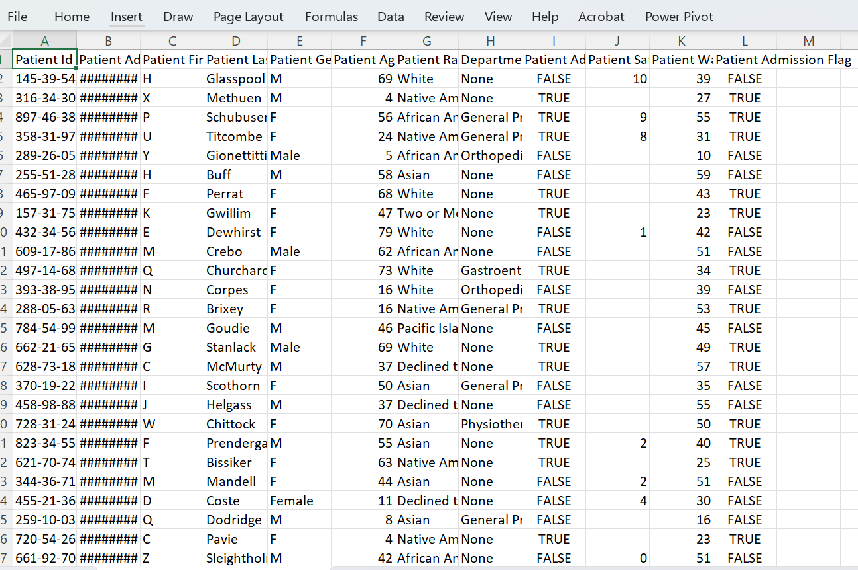
Appendix B — Key Excel Formulas / DAX Measures Used
List any important formulas, functions, or DAX measures used in the project:
- =IFERROR (VLOOKUP(...), "Not Found") — used for data validation
- =COUNTIF (range, criteria) — used to count duplicates
- Power BI DAX: Total Sales = SUM (Sales [Revenue]) — used in dashboard KPI card
- [Add your own formulas here]
Appendix C — AI Prompts Used
List the key prompts you used with Copilot or AI Chatbot during the project:
- Prompt 1: "Summarize this sales data and identify the top 5 performing regions."
- Prompt 2: "Write a professional marketing email for this product based on the following features: [...]"
- Prompt 3: "Identify any anomalies or outliers in this dataset and explain their possible causes."
- [Add the prompts specific to your project.]
Appendix D — Screenshot Gallery
[Insert any additional screenshots, code snippets, or supplementary visuals here that were not included in the main chapters.]

